Formal Methods project

Current Goal: Safety verification of da Vinci PSM/MTM system

Current Task: Do reachability analysis using HyPro/Flow\*

Progress so far:

Understand how the HyPro and Flow\* works

- Get to the know the toolbox through documents and example

- Since HyPro only takes hybrid system input, we choose to go with Flow\* as it takes both continuous system and hybrid system as input and the PSM/MTM dynamics is continuous

Dynamics of the PSM

- Derive the dynamics of the PSM → for accurate model, which includes the parallel linkage and the counter-weight on the arm, Radian suggested that the dynamics is too complicated for such short time so MTM is a better option

Dynamics of the MTM

- Derive the dynamics of the MTM → The dynamics model for 2 DoF and 3 DoF MTM are derived for the sake of simplicity

- State ODE form → the state ode form for both 2 DoF and 3 DoF model are successfully derived. The stability of the system has been tested using MATLAB ode function.

- Create the Flow\* model → create the model input file based on the MTM dynamics

Flow\* input

- Currently we're stuck here. The MTM model we created in Flow\* input format doesn't quite work with the toolbox as it violates some of the math operations and returns error. The template for MTM model file is the lac operon example from the manual.

lac operon model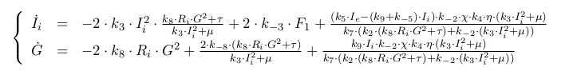

Current Progress:

Considering making the MTM hybrid systems by adding joint friction and create modes based on which direction the friction goes.